**Description:**

The Game is a 2d Form based game. It has the main character player which is controlled by the user and multiple enemies with different speed and power. You get score when you kill any enemy or pass any floor (Score can also be increased on number of fires hit the enemy). There are two levels in Game. Level one is simple static level. You have to kill all the Enemies to pass the level. The Second one is endless and moves from top to bottom and you have to pass to the upper floor by using stairs and kill the enemies with Gun.

**Game Characters:**

There are two characters in the Game but also there are some objects like walls, stairs floors.

* Player
* Enemy

**Rules and Interaction:**

There is not much rules about the game just enjoy the Game.

But before you play you must know the movements of Enemy and Player

* Enemies have different Powers depending on the type of color on there progress bar.
* Enemies with Dark Red color has the most power and are almost impossible to destroy, After that comes red ,blue, Khaki and at last Pink .
* Enemies have Different walking speed and fire randomly(The Random firing is also random{//Code})
* Enemy bullet should hit player atleast 20 times for player to get killed.
* Player Health also decreases when it get hits by Enemy Directly.
* Movement of Player is controlled by Up, Right, Left, Down Arrow keys. Space is for jump and ‘W’ is for fire.

**Goal of Game:**

The game is endless so there is not any Goal at all But you can create your own goal by creating the highest score.

**Features of Framework:**

The Framework I made provides following functionalities

1. Movement Framework
2. Collision Framework
3. Firing Framework
4. Power Bar Framework

Yes, my framework can be extended by the user if he or she wants too. Framework like Firing, Power Bar can not Only Be modified but a new Feature can also be added like collision of a new kind of object with another object. The Proper flow of code is explained in the ‘Usage Part of Framework’.

**Example Usage of Framework:**

1. **Gameobject**

To create a gameobject you have to pass following things to the addlist function in game.cs



1. **Movement Framework**

The movement framework is about the movement of any kind of object you can use this class if you want to add movement to any static object.

* 1. **IMovement.cs**

This class provides you the interface of Movement Framework.

There are some functions in this class which are must for any one to make in any movement class if he want to extend the functionality of that framework.

void move(GameObject obj, List<GameObject> gameobjects,IGame igame);

This Function is responsible for moving the object depending on the type of movement.

void scroll(PictureBox p);

This Function is responsible for moving the object a little down . it works like gravity but to only those classes where you give there definition.

bool getDirection();

This Function returns the direction of where the gameobject is facing.

* 1. **Player**

This class moves the object on the base of keyboard movements.

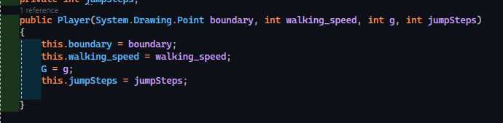

* 1. **Enemy**

This class moves the enemy on the random movements .

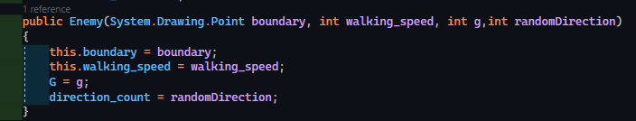

* 1. Floor and Stair

These classes do not implement any movement. This will make your object static.

1. **Firing Framework**

The Firing framework is about the Firing of any kind of object you can use this class if you want to add firing to any object.

It has three classes and one interface in it:

* 1. Player Fire

Player fire class generates fire on the base of keyboard keys.

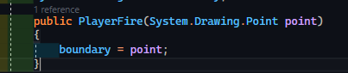

* 1. Enemy Fire

Enemy fire class adds functionality to an object by generating random fires .

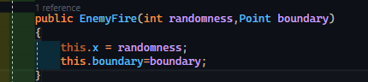

* 1. no Fire

This is the class you can add to your object if you do not want to give that object any firing option.

1. **Collision Framework**

The Collision framework is about the Collision of any kind of object you can use this class if you want to add Collision to any object.

* 1. Collision Class

This is the collision which whose implementation is like this

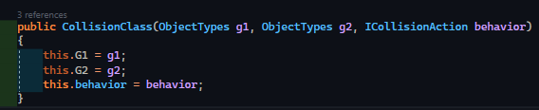

* 1. Bullet Collision

This collision behavior will remove enemy and the other object which hits it.(like Bullet)

* 1. Enemy Bullet Collision

This collision will happen when enemy bullet hits player .It will decrease player health based on enemy hits by invoking raise enemy hit event and also removes enemy bullet with remove player bullet remove.

* 1. Player Collision

This collision will raise player hit event which will decrease player health.

1. **Progress Bar Framework**

This framework is about the Progress bar of any kind of object you can use this class if you want to add Progress Bar to any object.

* 1. ProgressBarClass

You can add this class if you want to add health system to the object.

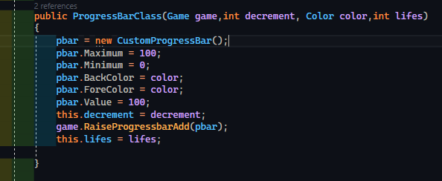

* 1. NoProgressBar

You can add this class to your object if you do not want to give the functionality of health to a object